The reality of illusions

Alex Davis Character
Born in 1975
Went to school for neuropsychologist
Studies brain/behavior relationships especially cognitive function.
Read Rene Descartes - Meditations on first philosophy - Principals of philosophy
The Oakridge brothers the song the journey
You don't know how it feels Tom Petty
Zack brown Colder Weather
I musta picked a bad time to fall in love Grand Funk Railroad
Ship of fools Robert Plant
Seal Crazy
Seven Year Ache from
Believable, intriguing, adventitious

Hypnotized Fleetwood mac
This gave me the idea of Alex doing what Monroe did in a lab. Discovers powers/levels of mind previously unknown.

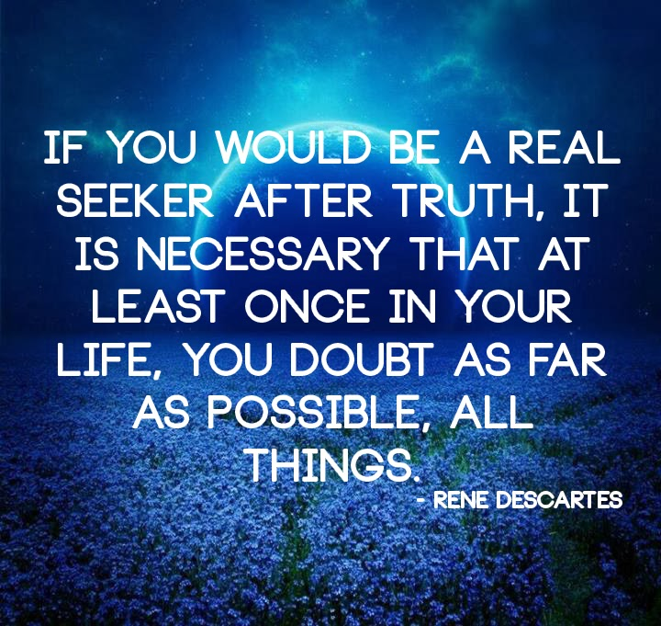
Also, pattern a character after Bruce Willis in the fifth element and Hans solo in Star Wars. A rebel new age adventurer who pushes the limits of mind exploration with psychedelics and crazy adventures.

Alex was out on Saturday night with some buddies having a good time when he met Betty. She was with friends drinking whiskey and water, dancing, and having fun. They started dancing, had a good time but he didn't get her phone number.

The next morning he went to church and saw her singing in the choir. The preachers daughter.

Alex had a spiritual experience young. Went to church where he met Betty. This sets up some interesting discussions between him and Betty. Betty is a little on the wild side. He pursues her in the little time he has while perusing his career.

He couldn't convince her to come to Colorado (Pittsburg) where he went to a university
Longed for her. Kept in touch. He feels driven by a purpose, he has to pursue his research. He looks forward to the day they can be together. What holds her back?

He meets a friend in college who studies robotics. He is studying neuropsychology. Together they found a startup making robots out of ants. Together they discover insights into the mind and build robots to mimic the natural interactions of mind with material bodies.

Alex felt certain he and Betty were meant to be together. She didn't seem as certain.

Alex's motivations
114:7.3 (1257.3) Mortals of the realm are chosen for service in the reserve corps of destiny on the inhabited worlds because of:
114:7.4 (1257.4) 1. Special capacity for being secretly rehearsed for numerous possible emergency missions in the conduct of various activities of world affairs.
114:7.5 (1257.5) 2. Wholehearted dedication to some special social, economic, political, spiritual, or other cause, coupled with willingness to serve without human recognition and rewards.
114:7.6 (1257.6) 3. The possession of a Thought Adjuster of extraordinary versatility and probable pre-Urantia experience in coping with planetary difficulties and contending with impending world emergency situations.

Alex is a cross between Will Rogers and

Richard Gere
Alex minored in psychology
He spends time exploring the mind in deep meditation. He has experiences, gets insights into his artificial intelligence work. Similar to how tesla did. Tesla knew there was a central transmitting station for mind and he was in touch with it.

